**Buchstabenliste, Schreibschrift, Handschrift**

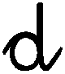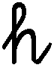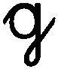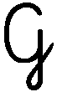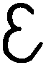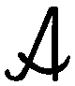

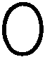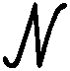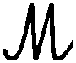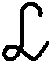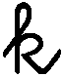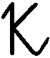

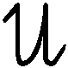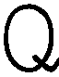

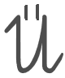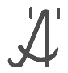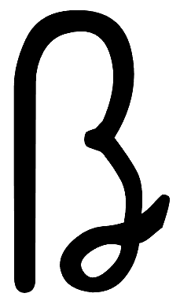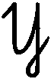

**1 2 3 4 5 6 7 8 9 10**

|  |  |
| --- | --- |
|  | Download **Word DOCX** diese Seiten / these pages    /  Завантажте ці сторінки / قم بتنزيل هذه الصفحات  [http://kleine-deutsch-hilfe.at/Schreibuebungen_ABC-123_Handschrift.**docx**](http://kleine-deutsch-hilfe.at/Schreibuebungen_ABC-123_Handschrift.docx) |
|  | Download **Adobe PDF** diese Seiten / these pages    /  Завантажте ці сторінки / قم بتنزيل هذه الصفحات  [http://kleine-deutsch-hilfe.at/Schreibuebungen_ABC-123_Handschrift.**pdf**](http://kleine-deutsch-hilfe.at/Schreibuebungen_ABC-123_Handschrift.pdf) |

**Buchstaben, Übungszeilen**

(Quellen: <http://vs-material.wegerer.at/deutsch/pdf_d/bst_erarb/schreibschrift_bst.pdf>   
<http://vs-material.wegerer.at/deutsch/pdf_d/schreiben/ab/SchreibschriftbuchstabenzumNachspuren.pdf> )

A 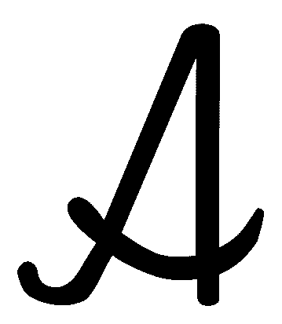

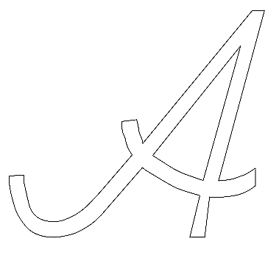     

|  |  |
| --- | --- |
|  |  |
|  |
|  |  |

a 

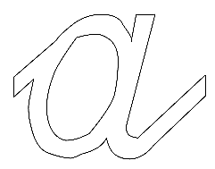     

|  |  |
| --- | --- |
|  |  |
|  |  |
|  |  |

B 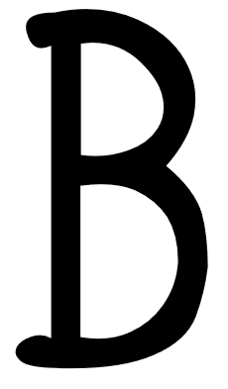

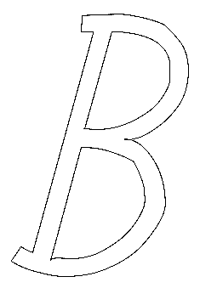     

|  |  |
| --- | --- |
|  |  |
|  |
|  |  |

b 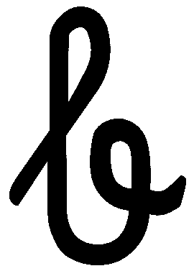

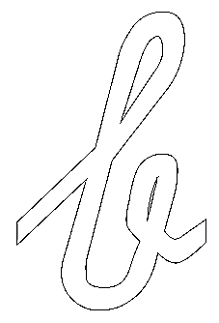     

|  |  |
| --- | --- |
|  |  |
|  |
|  |  |

C 

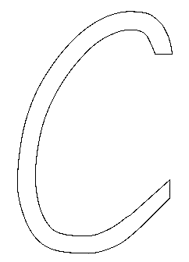     

|  |
| --- |
|  |
|  |
|  |

a 

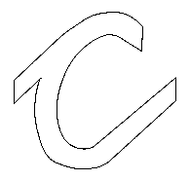     

|  |
| --- |
|  |
|  |
|  |

D 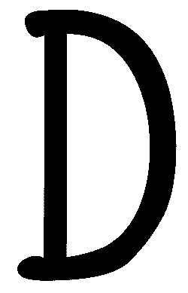

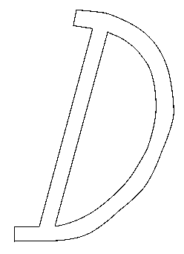     

|  |
| --- |
|  |
|  |
|  |

d 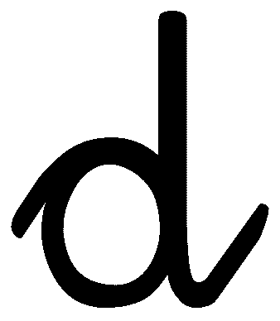

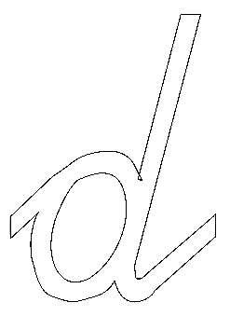     

|  |  |
| --- | --- |
|  |  |
|  |
|  |  |

E 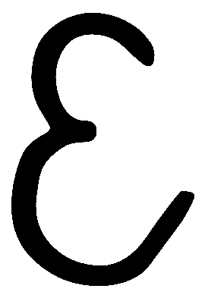

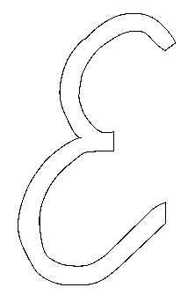     

|  |
| --- |
|  |
|  |
|  |

e 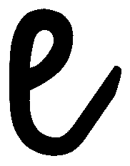

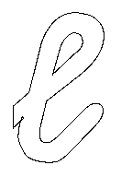     

|  |
| --- |
|  |
|  |
|  |

F 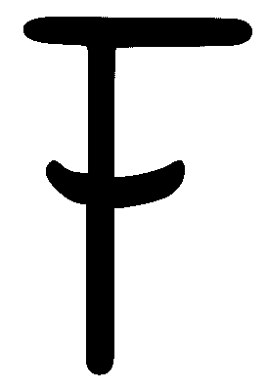

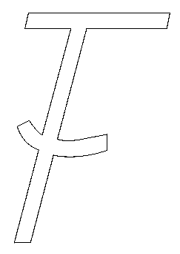     

|  |
| --- |
|  |
|  |
|  |

f 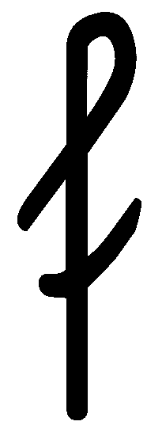

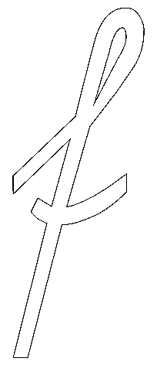     

|  |  |
| --- | --- |
|  |  |
|  |
|  |

G 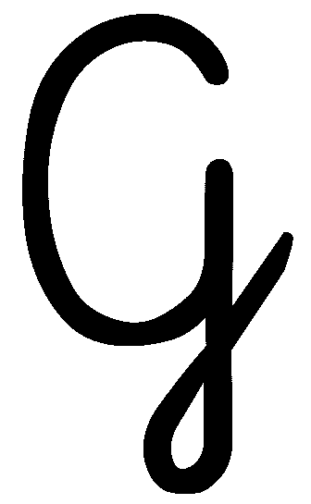

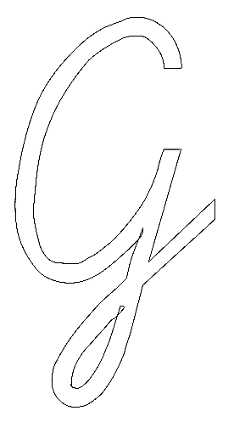     

|  |  |
| --- | --- |
|  |  |
|  |
|  |

g 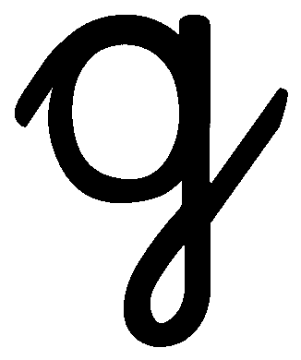

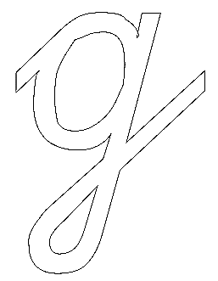     

|  |  |
| --- | --- |
|  |  |
|  |  |
|  |

H 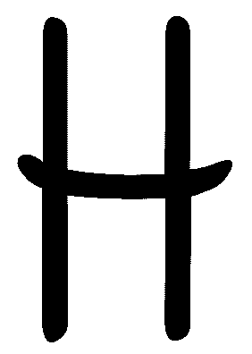

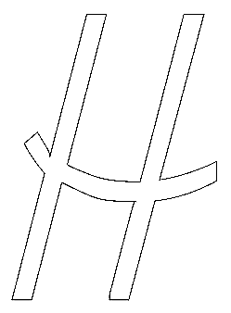     

|  |
| --- |
|  |
|  |
|  |

h 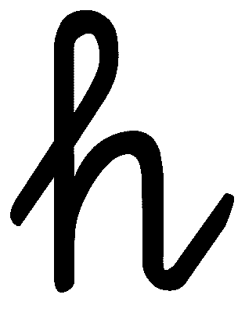

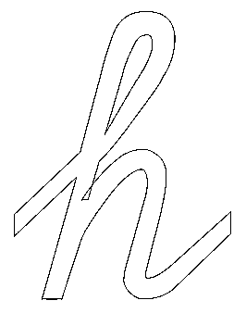     

|  |  |
| --- | --- |
|  |  |
|  |
|  |  |

I 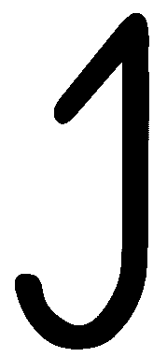

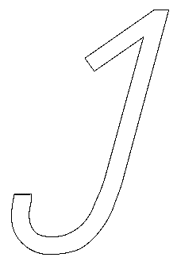     

|  |
| --- |
|  |
|  |
|  |

i 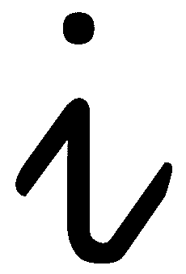

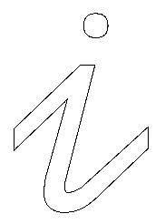     

|  |
| --- |
|  |
|  |
|  |

J 

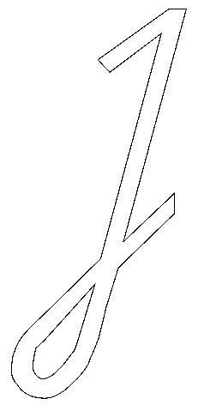     

|  |  |
| --- | --- |
|  |  |
|  |
|  |

j 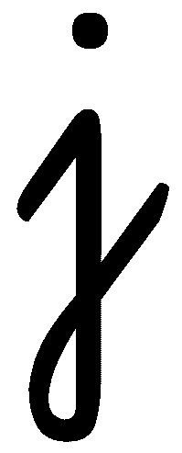

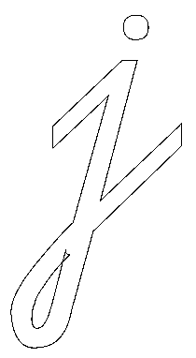     

|  |  |
| --- | --- |
|  |  |
|  |  |
|  |

K 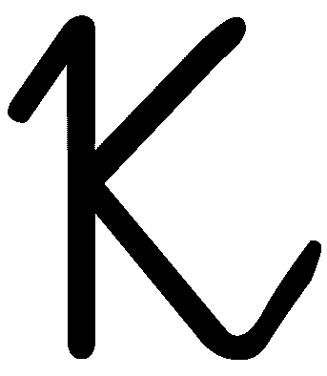

     

|  |
| --- |
|  |
|  |
|  |

k 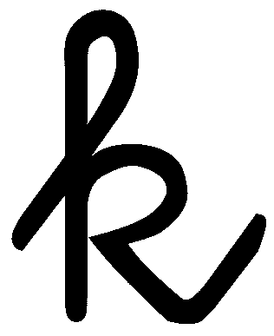

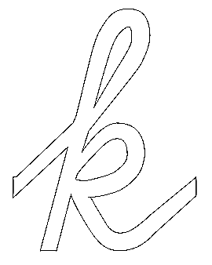     

|  |  |
| --- | --- |
|  |  |
|  |
|  |  |

L 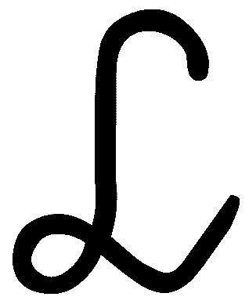

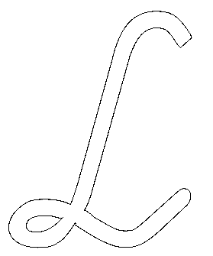     

|  |
| --- |
|  |
|  |
|  |

l 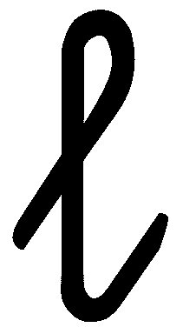

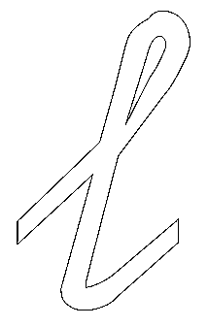     

|  |  |
| --- | --- |
|  |  |
|  |
|  |  |

M 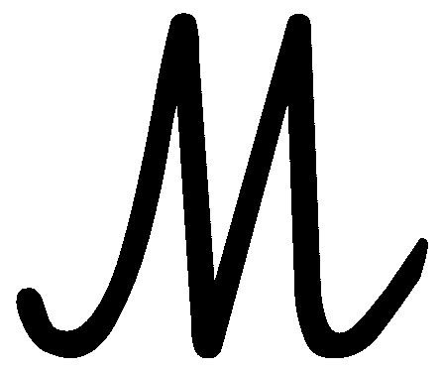

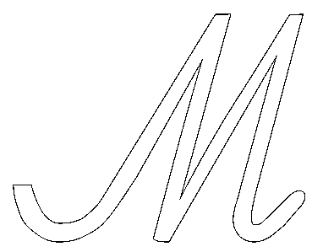     

|  |
| --- |
|  |
|  |
|  |

m 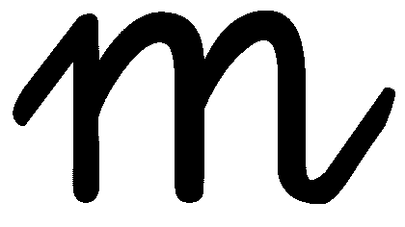

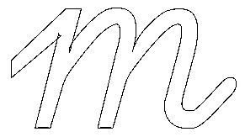     

|  |
| --- |
|  |
|  |
|  |

N 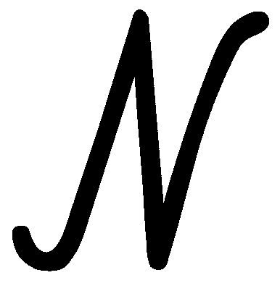

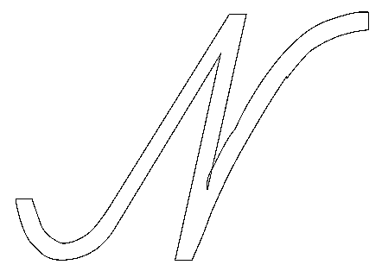     

|  |
| --- |
|  |
|  |
|  |

n 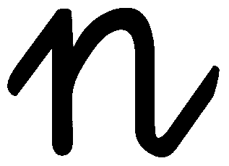

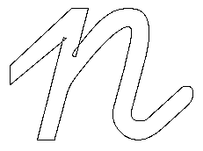     

|  |
| --- |
|  |
|  |
|  |

O 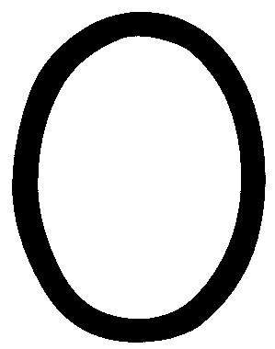

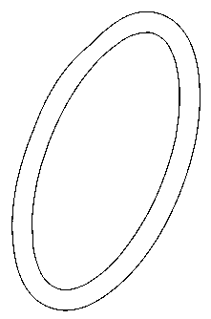     

|  |
| --- |
|  |
|  |
|  |

o 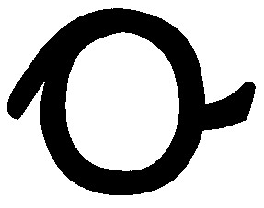

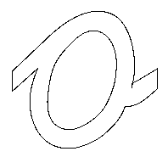     

|  |
| --- |
|  |
|  |
|  |

P 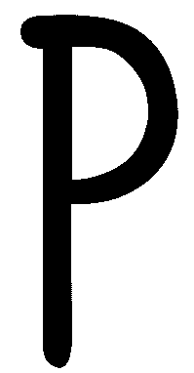

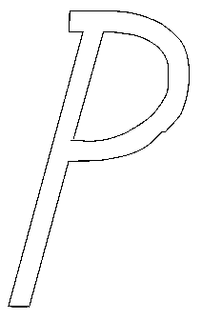     

|  |
| --- |
|  |
|  |
|  |

p 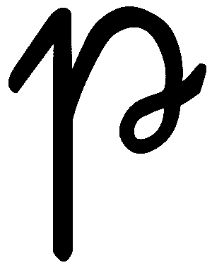

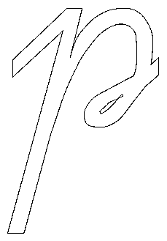     

|  |  |
| --- | --- |
|  |  |
|  |  |
|  |

Q 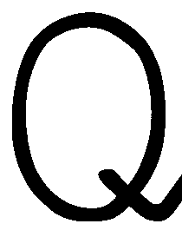

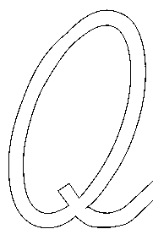     

|  |
| --- |
|  |
|  |
|  |

q 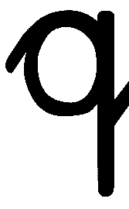

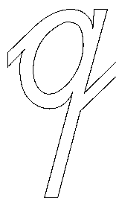     

|  |
| --- |
|  |
|  |
|  |

R 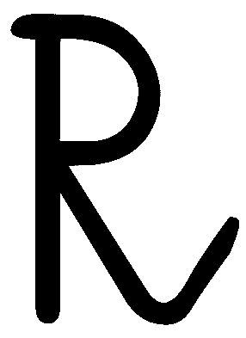

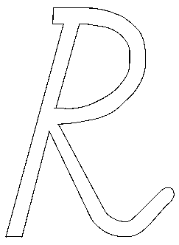     

|  |
| --- |
|  |
|  |
|  |

r 

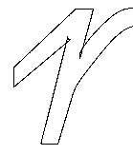     

|  |
| --- |
|  |
|  |
|  |

S 

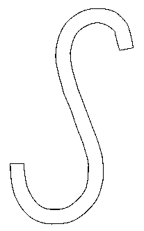     

|  |
| --- |
|  |
|  |
|  |

s 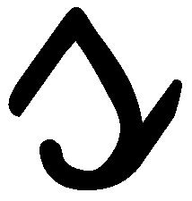

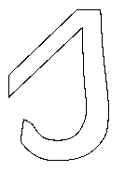     

|  |
| --- |
|  |
|  |
|  |

T 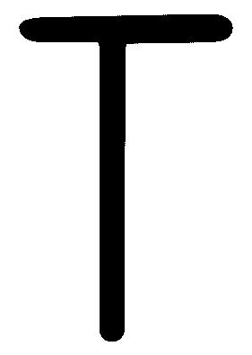

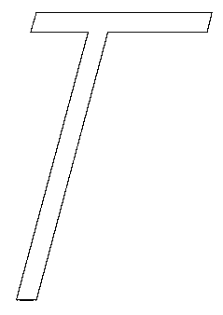     

|  |
| --- |
|  |
|  |
|  |

t 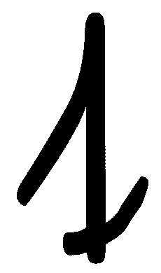

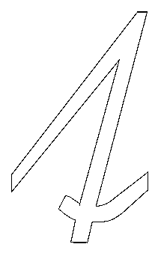     

|  |  |
| --- | --- |
|  |  |
|  |
|  |  |

U 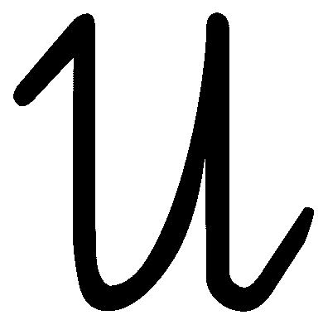

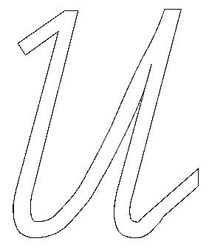     

|  |
| --- |
|  |
|  |
|  |

u 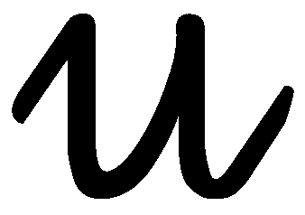

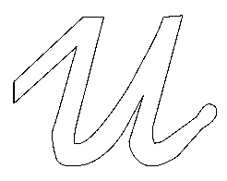     

|  |
| --- |
|  |
|  |
|  |

V 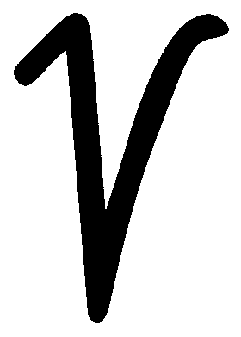

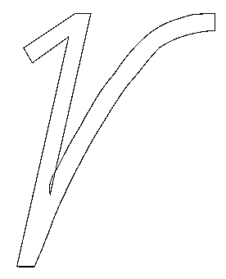     

|  |
| --- |
|  |
|  |
|  |

v 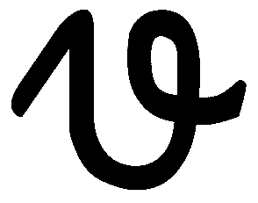

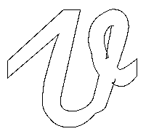     

|  |
| --- |
|  |
|  |
|  |

W 

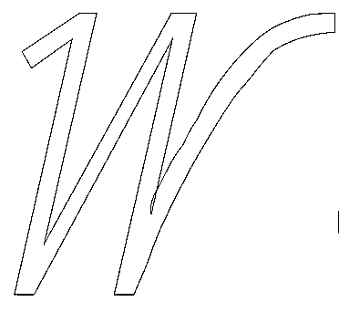     

|  |
| --- |
|  |
|  |
|  |

w 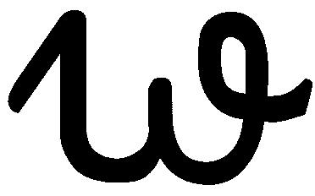

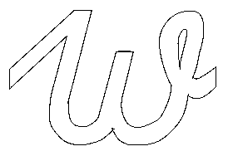     

|  |
| --- |
|  |
|  |
|  |

X 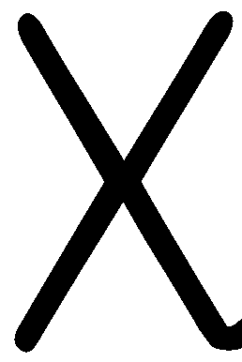

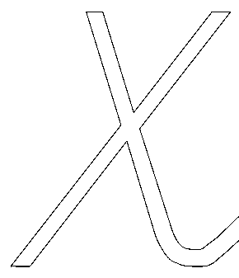     

|  |
| --- |
|  |
|  |
|  |

x 

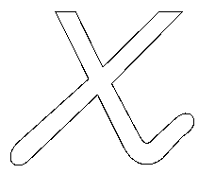     

|  |
| --- |
|  |
|  |
|  |

Y 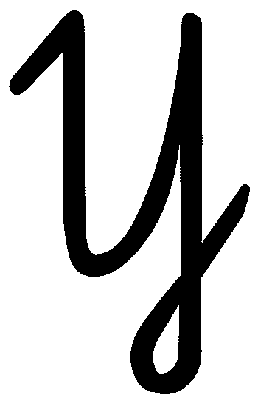

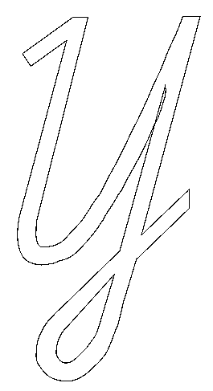     

|  |  |
| --- | --- |
|  |  |
|  |
|  |

y 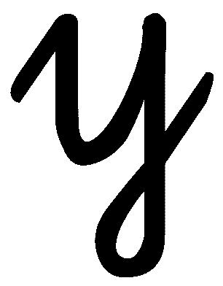

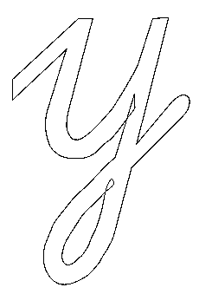     

|  |  |
| --- | --- |
|  |  |
|  |  |
|  |

Z 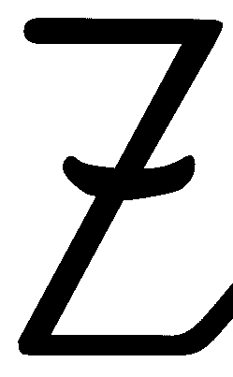

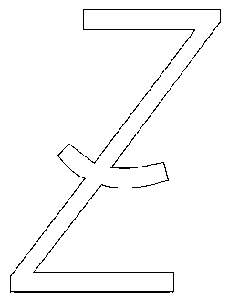     

|  |
| --- |
|  |
|  |
|  |

z 

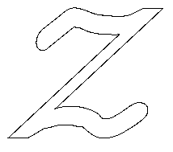     

|  |  |
| --- | --- |
|  |  |
|  |  |
|  |  |

ß 

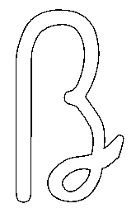     

|  |  |
| --- | --- |
|  |  |
|  |
|  |  |

Ä 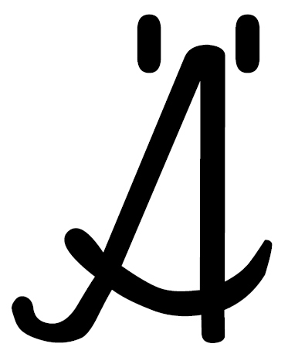

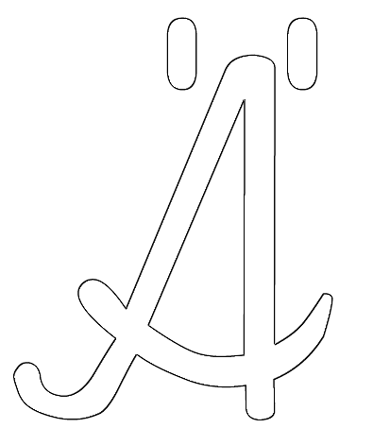     

|  |  |
| --- | --- |
|  |  |
|  |
|  |  |

ä 

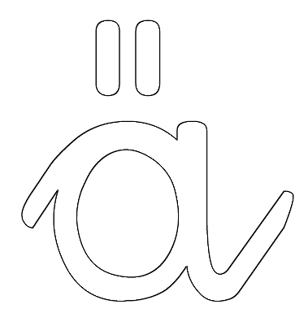     

|  |  |
| --- | --- |
|  |  |
|  |
|  |  |

Ö 

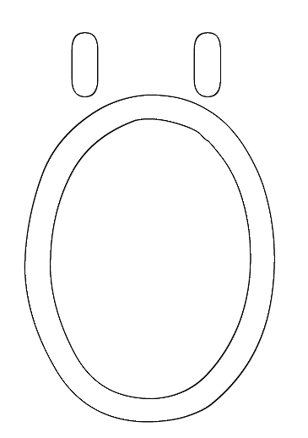     

|  |  |
| --- | --- |
|  |  |
|  |
|  |  |

ö 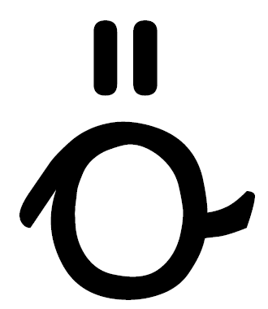

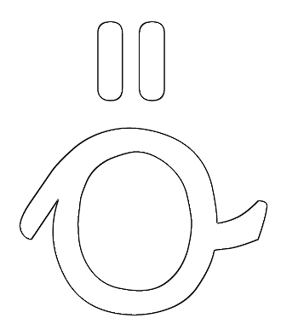     

|  |  |
| --- | --- |
|  |  |
|  |
|  |  |

Ü 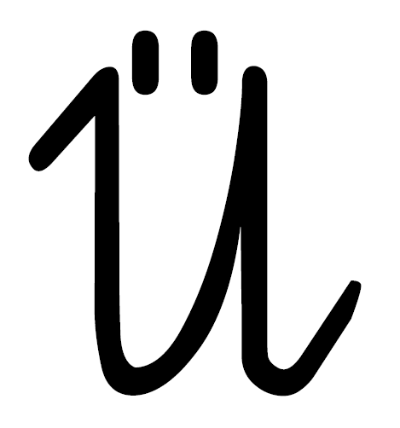

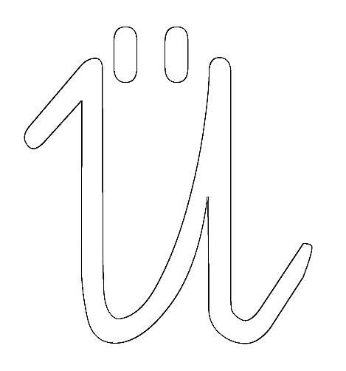     

|  |  |
| --- | --- |
|  |  |
|  |
|  |  |

ü 

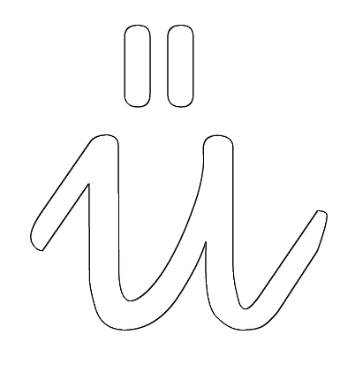     

|  |  |
| --- | --- |
|  |  |
|  |
|  |  |

**Ziffern.**

(Quelle: <http://vs-material.wegerer.at/mathe/pdf_m/mengen_zaehlen/Ziffern0-10sw.pdf> )

